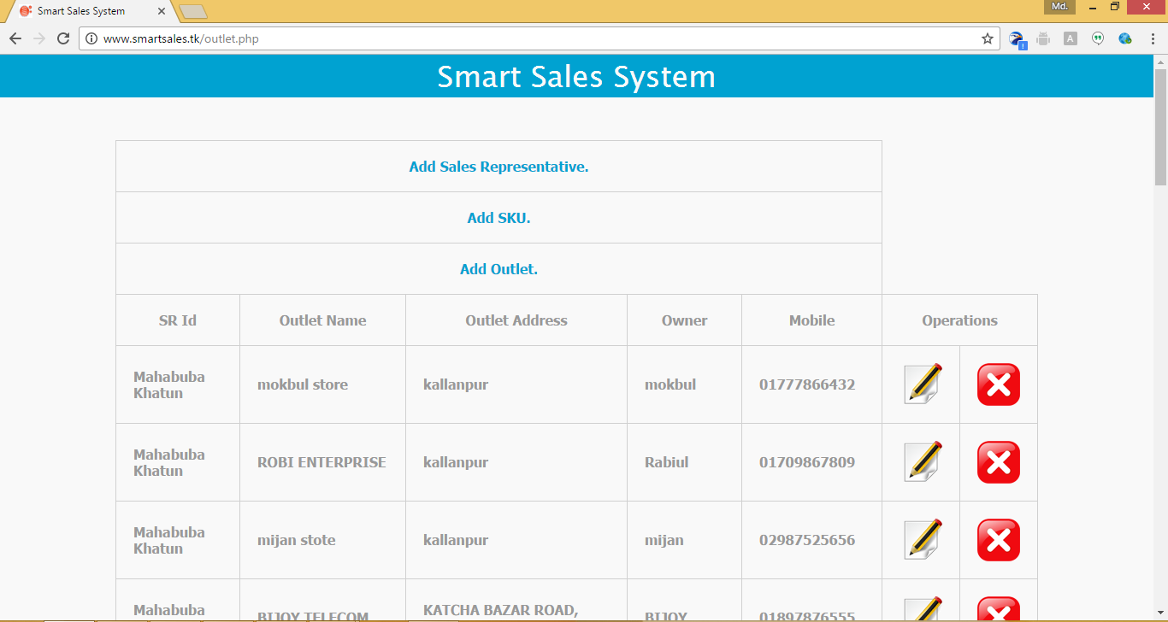Outlet CRUD and Mobile Application Process:

To Create Outlet Click on Add Outlet

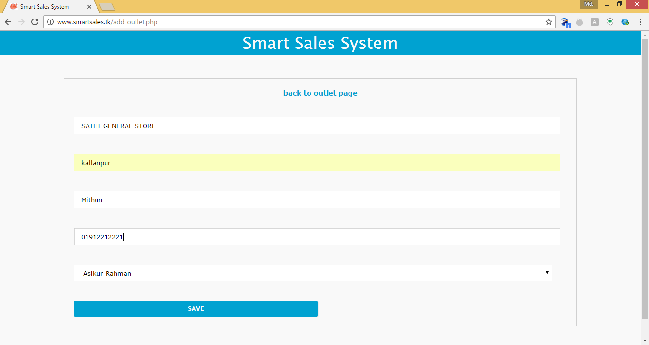

Type Outlet information and Click on Save Button

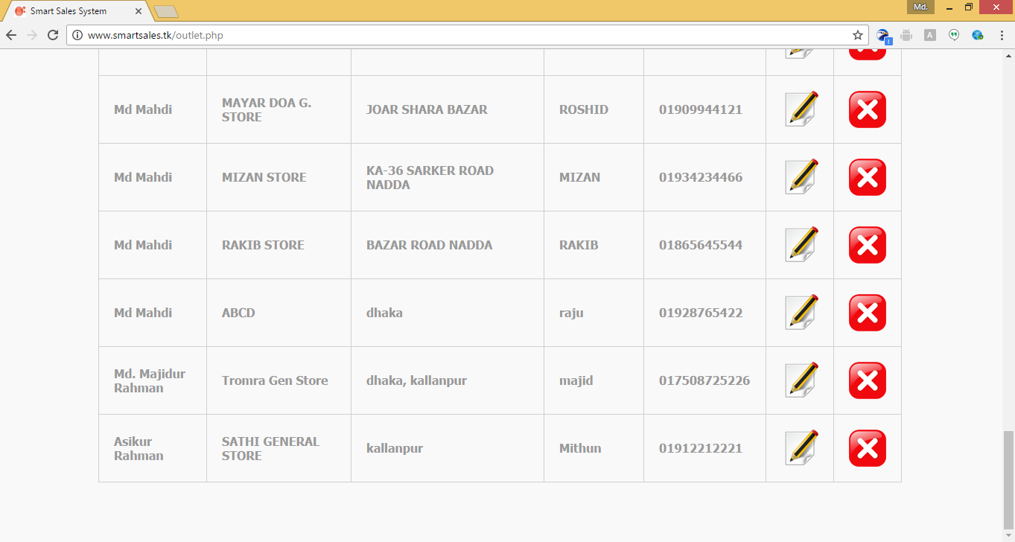

Delete Outlet Information

View Outlet Details Information

Update Outlet Information

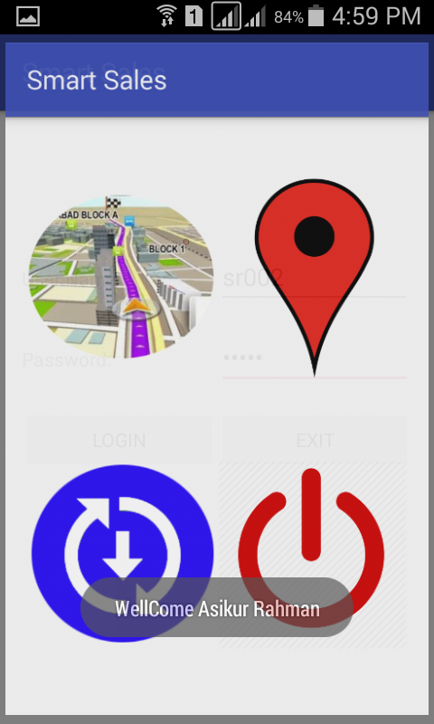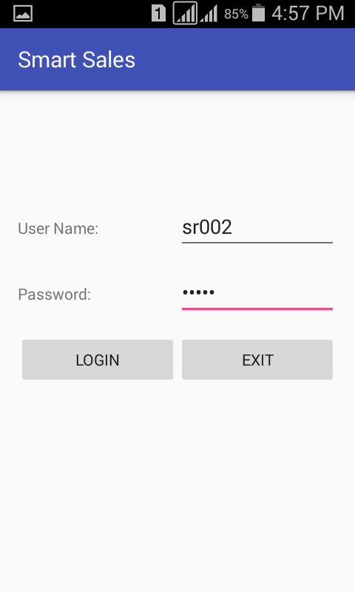

Create New Outlet From Mobile App

Sales Representative Routes Outlet List For Sales order

Sync Mobile new Data to Server And Sync From Server

Logout

Login On Assigned Sales Representative

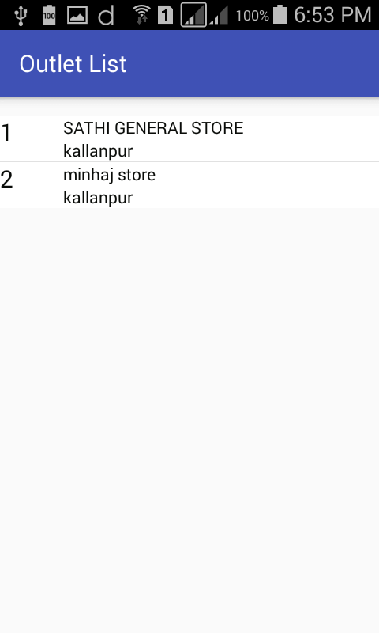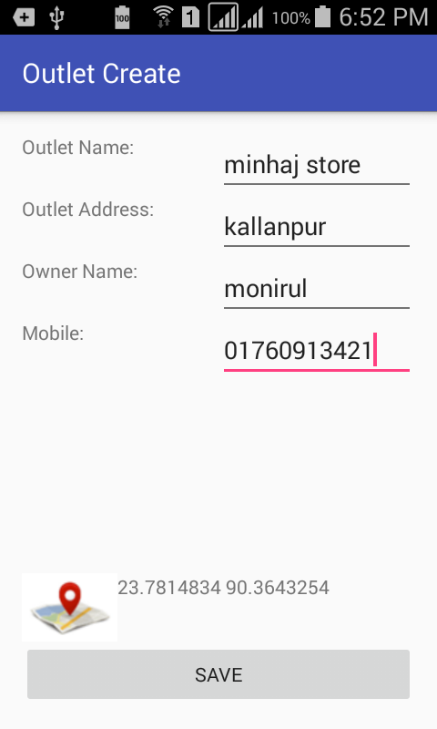

View Outlet Created From Server or Mobile and Take order

Save Outlet

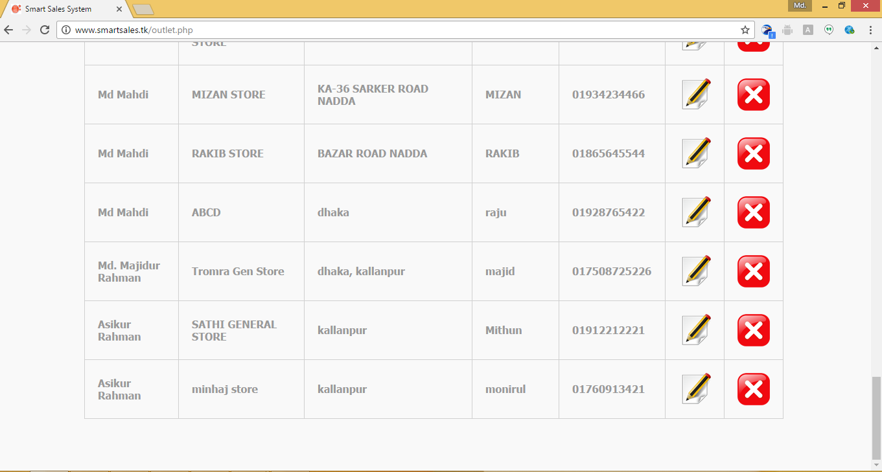

View Outlet Details Information